**Maroba Advantage**

Experience the choice, the service, and the lifestyle…

Maroba Advantage adds those little extras that enhance life in your new home.

Maroba’s Advantage Services is a condition of entry and is compulsory.

These services are available for a small additional daily fee of $29/day for non-supported residents and $5/day for supported residents. A Supported person are those persons who are assessed as not being subject to paying a RAD/ DAP or a RAC/DAC at time of entry

Culture and Social

Environment

* Flat-screen LED smart television in your room
* Personal in-room air-conditioning
* Wi-Fi internet

Wellbeing

* Gymnasium
* Morning exercise group and walking groups
* 1:1 Social and/or Spiritual Support
* Mental and Sensory stimulation
* Arts and Craft
* Cooking Demonstration
* Weekly Live Entertainment
* Fortnightly bus outings
* Fortnightly Happy Hour
* Monthly Birthday Parties
* Monthly Theme Days

Food and Alcohol

* Cooked breakfast three days per week
* Additional hot menu choice at lunch
* After-hours menu available
* Meals prepared fresh on premises with

on-site chef

* Glass of wine or beer with main meal

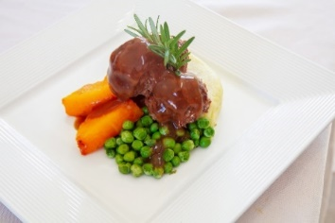Services

* On-site Oral Hygienist
* On-site Speech Pathologist
* On-site Spiritual Care

General

* Newspaper and magazines to lounges
* In-house movie library
* Netflix on the communal television as well as on the large screen in the cinema room
* Self-service café for residents and families