27th June 2025

Dear Residents, Family and Friends,

Reforms on hold …but Maroba is still moving forward towards the new Reforms implementation date on the 1st November 2025. We look forward to continuing our endeavour to partner with all our residents and their families and friends to ensure we deliver the wholistic care and services you desire. Work continues in the background as we are still waiting for the Government to provide the necessary rules that support and guide aged care providers to best deliver on the new standards.

Yesterday NSW Health provided an important update to the Medical and Health sectors regarding Influenza and other viruses. It is clear that Influenza and Covid are circulating at Moderate levels and is expected to increase rapidly over the next few weeks. Sadly, Vaccination rates are low across all age groups across NSW.

Fortunately, our resident population responded positively to the call for vaccinations which will provide better protection but not complete immunity. Unfortunately, many visitors are not vaccinated and may be at greater risk of bringing Colds and flu into Maroba .

* On average, each year in Australia, influenza results in an estimated 300,000 GP consultations, 18,000 hospitalisations and 3,500 deaths.
* In 2024, Australian studies suggested vaccinated people were about 55% less likely to attend general practice or be hospitalised with influenza than unvaccinated people.
* The top barriers to influenza vaccination for older people are not thinking they need it, perceived protection by diet and exercise, and the belief they can stay safe with good hygiene measures.

We currently have 2 cases of Parainfluenza and 1 case of Rhino Virus within the facility. All 3 residents are in isolation.

This is our reminder to all visitors to Maroba to get vaccinated, stay vigilant and follow all reasonable instructions to keep our entire community safe from communicable diseases such as Influenza, Covid, RSV, Pneumonia and Shingles just to name a few.

New residents may not have their vaccinations up to date, so it is very important to consider accepting the vaccination services offered here at Maroba.

Travellers remain at high risk as does mingling in crowded venues or close contact with any infected person (who may or may not have symptoms).

Our multi-pronged approach works, so we ask that you do not visit if you are unwell or have even the slightest respiratory or gastrointestinal symptoms. Keep testing before each visit and make sure you remind other family members of the requirement for RAT testing to visit Maroba. The option to wear a mask is something to think about if you wish to protect yourself in the event that you are Immunocompromised or the person you are visiting is immunosuppressed. We are depending on you and Trust you will co-operate with these precautions for the sake of everyone not just your loved one.

**Current COVID guidelines at Maroba:**

**For Residents**

• Residents undergo a Rapid Antigen Test (RAT) when they are symptomatic and if there has been an exposure to a Covid positive person or if there is high risk within our community. PCR testing is being carried out if the RAT is negative and the resident has ongoing symptoms. If an outbreak occurs, then all residents in that area will undergo testing for respiratory illness. Please know that if your family member tests positive, we will update you as soon as possible by phone.

**For Visitors**

• all regular visitors need only undertake a RAT test once a week unless you have been travelling, attending large events or have been exposed to any person with Covid or other Respiratory Infection. I suggest it be on your first visit of the week being Monday to Sunday. All other visitors who are not regularly visiting we ask that you undertake a RAT prior to every visit. RATs are available at Reception and at the front door.

• Please write the date of the test on the RAT cartridge before taking a photo or placing it in a secure clear bag. Keep a photo of your RAT test on your phone as proof and present it to reception or a staff member after hours. Free RAT kits are still available at our reception, please feel free to take some home to test before your visit. Do not leave the kits in your car as they must be kept at a stable temperature to be effective.

• No restrictions on the number of visitors to Non Covid effected residents.

• There are no visiting hours however for the safety of our residents the doors are locked from sunset until sunrise. During these times visitor access is by pressing the call button at the entrance, so a staff member is aware of your arrival and can let you in…please be patient! Dinner commences around 5.00pm and after dinner residents are usually settling in for the night. Arrangements can be made with staff if you are taking your loved one out during these hours to have easy access on your return.

**For Staff, Volunteers, Contractors, Agency Staff & Students**

• Our staff, volunteers, students and Agency Staff will continue to RAT test as per staff notices before coming onsite at Maroba.

• Volunteers, Contractors, Agency Staff, and Students will continue to check in using our new ‘Loop Safe’ Electronic Check in system.

If you have concerns with our approach, please call us to discuss. Alternatively, you can contact:

* Older Persons Advocacy Network (OPAN) on 1800 700 600
* The Aged Care Quality and Safety Commission on 1800 951 822
* Senior Rights Service 1800 424 079

For additional information, please contact reception at

4935 0300 during office hours or email us at [enquiries@maroba.om.au](mailto:enquiries@maroba.om.au).

Warm Regards

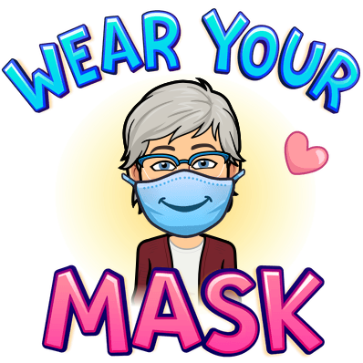Viv Allanson OAM - CEO Maroba